**WEEK – 5 Assignments**

**ASP. NET Core 8. 0 Web API**

**Mandatory hands-on :-**

**6. WebApi_Handson :**

**Kafka Integration with C#:**

**Hands On:**

1. Create a Chat Application which uses Kafka as a streaming platform and consume the chat messages in the command prompt.

2. Create a Chat Application using C# Windows Application using Kafka and consume the message in different client applications.

**1. Create a Chat Application which uses Kafka as a streaming platform and consume the chat messages in the command prompt :**

**First app “KafkaChatConsumer” :**

**Code :**

[**Program.cs**](http://program.cs) **:**

| **using System; using Confluent.Kafka;  class Program {  static void Main()  {  var config = new ConsumerConfig  {  BootstrapServers = "localhost:9092",  GroupId = "chat-group",  AutoOffsetReset = AutoOffsetReset.Earliest  };   using var consumer = new ConsumerBuilder<Null, string>(config).Build();  consumer.Subscribe("chat-message");  Console.WriteLine("Listening for messages. Press Ctrl+C to exit.");   try  {  while (true)  {  var consumeResult = consumer.Consume();  Console.WriteLine($"Received: {consumeResult.Message.Value}");  }  }  catch (OperationCanceledException) { }  finally  {  consumer.Close();  }  } }** |
| --- |

**Second app “KafkaChatProducer” :**

**Code :**

[**Program.cs**](http://employeecontroller.cs) **:**

| **using System; using System.Threading.Tasks; using Confluent.Kafka;  class Program {  static async Task Main(string[] args)  {  var config = new ProducerConfig { BootstrapServers = "localhost:9092" };   using var producer = new ProducerBuilder<Null, string>(config).Build();  Console.WriteLine("Enter your chat messages (type 'exit' to quit):");   while (true)  {  var msg = Console.ReadLine();  if (msg.ToLower() == "exit") break;   await producer.ProduceAsync("chat-message", new Message<Null, string> { Value = msg });  }  } }** |
| --- |

**OUTPUT :**

**Both Producer side and Consumer side output of chats :**

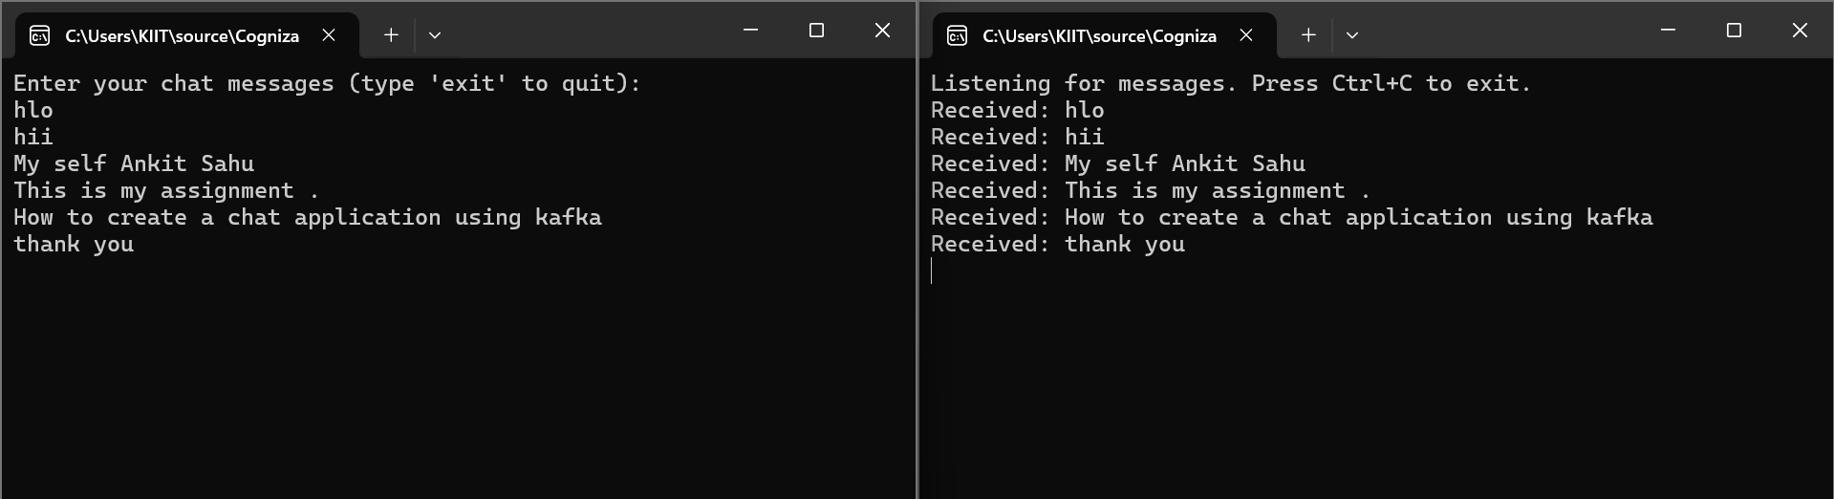

**Kafka Server Running:**

**.\bin\windows\kafka-server-start.bat .\config\server.properties :**

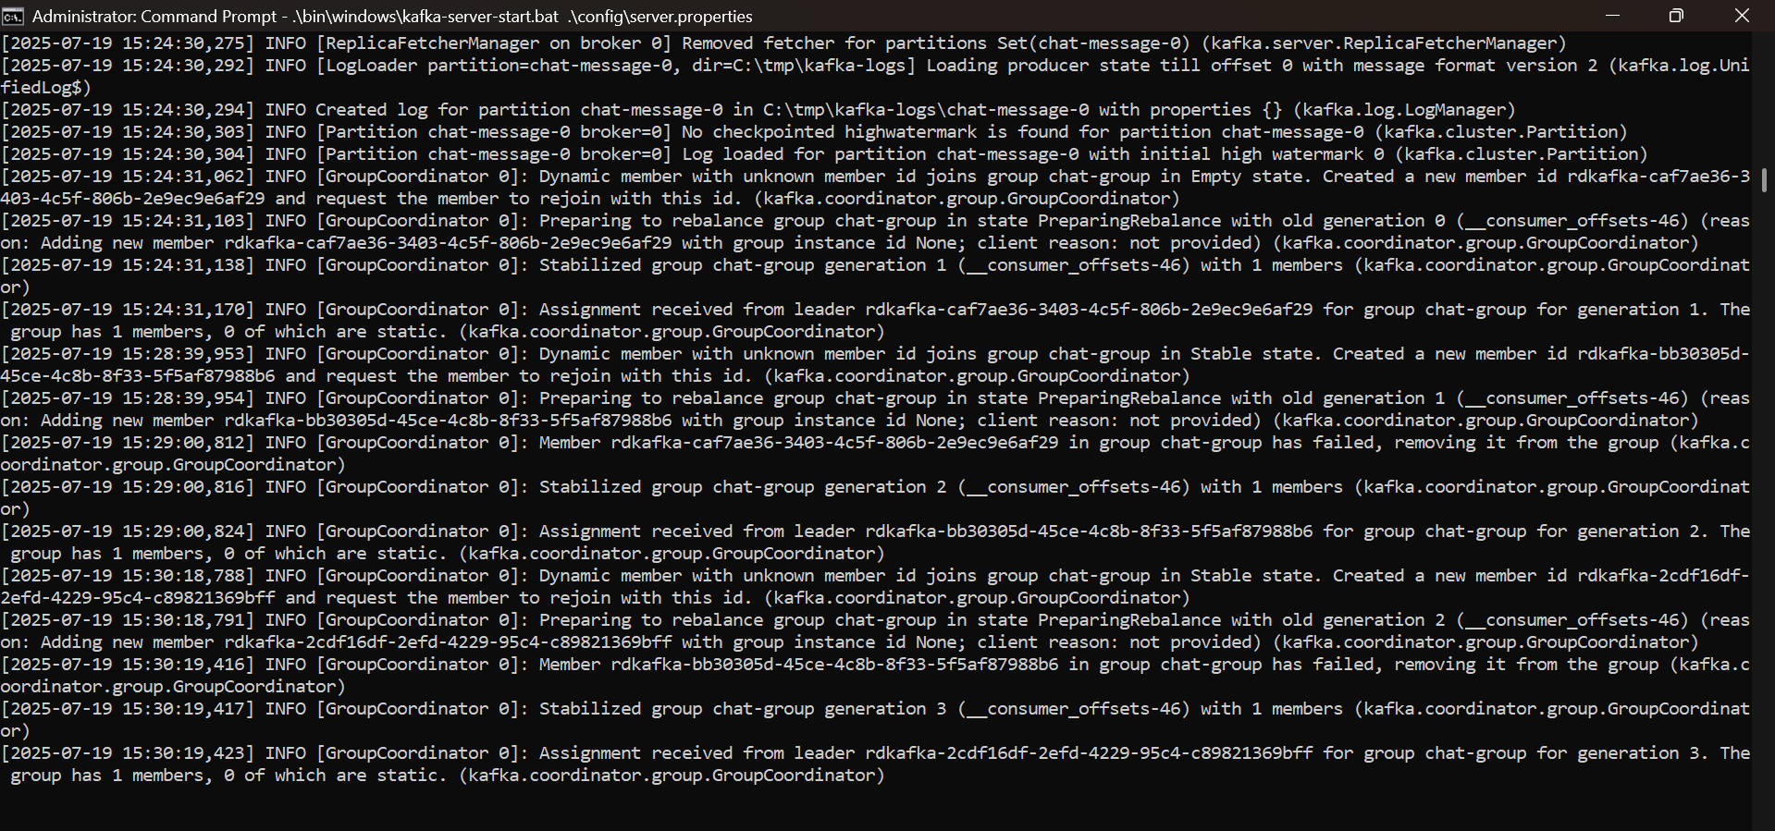

**Zookeeper Running:**

**.\bin\windows\zookeeper-server-start.bat .\config\zookeeper.properties :**

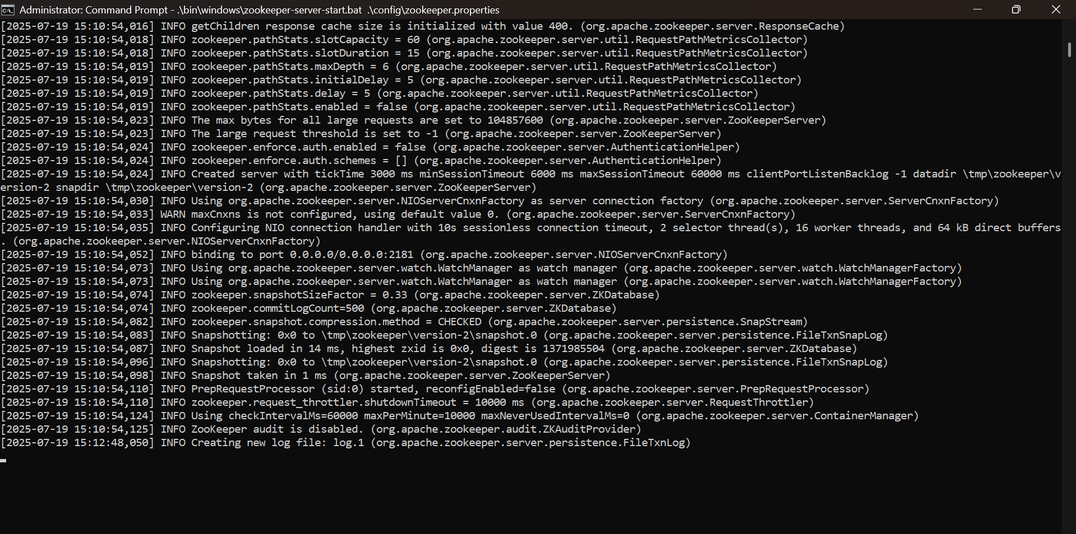

**Topic Created :**

